**Mini Project – tableau project for data visualization of car data**

**22nd Dec– 2019**

**Submitted**

By: Shilpa Pandey

**Table of Content**

**1. Project Objectives**

**2. insights in the story caption:**

**3. Usage of parameters and filters to avoid visual clutter**

**4. Story layout**

**5. Appropriate chart**

**URL :**

<https://public.tableau.com/shared/SZ34GBC8Q?:display_count=y&:origin=viz_share_link>

**1. Project Objectives: to analyze the car data from high level and get useful information**

**2. insights in the story caption:**

the story is about the cars which is having maximum number of insurance claims based on many criteria’s.

the claim frequency and old claims are similar.

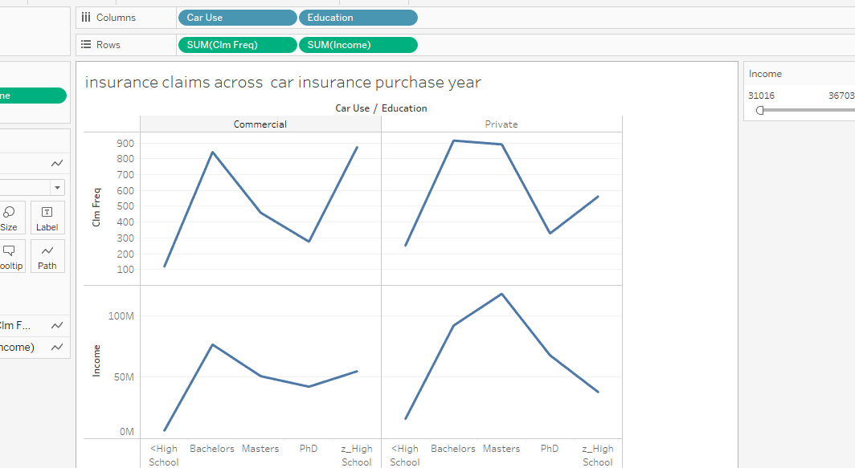

Some chart to depict people with education qualification of bachelors and master have high income

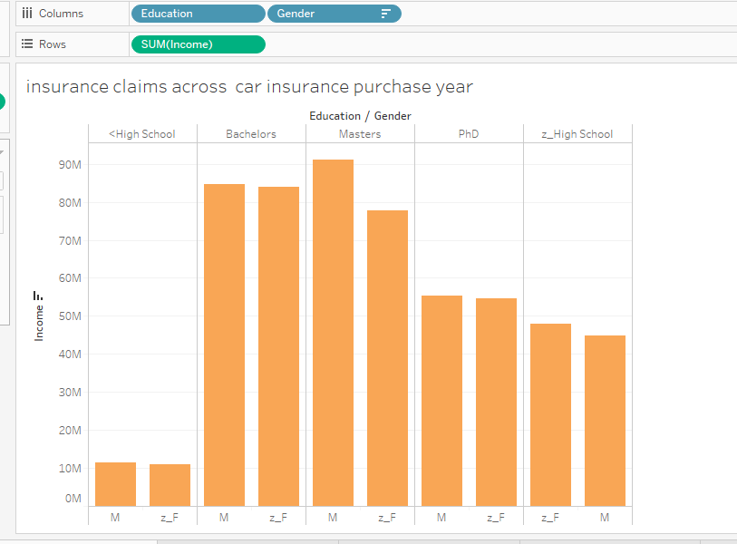

Used tha labels:

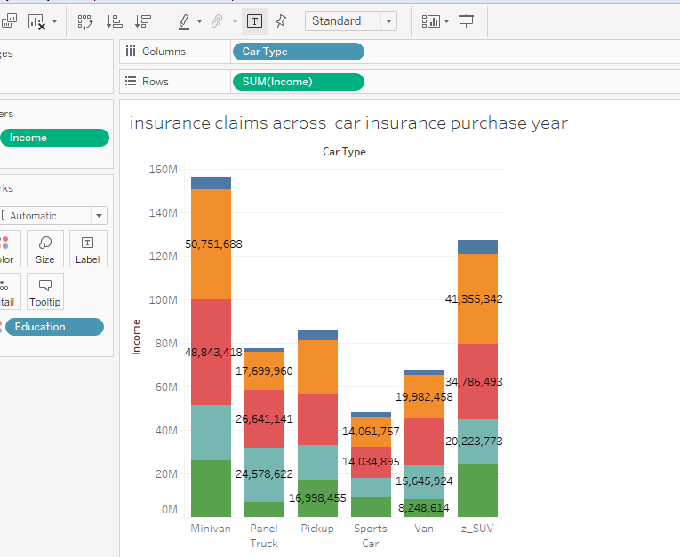

**3. Usage of parameters and filters to avoid visual clutter**

In 1st dashboard used a parameter to select multiple criteria for occupation, urbancity, marital status, car type to define income range:

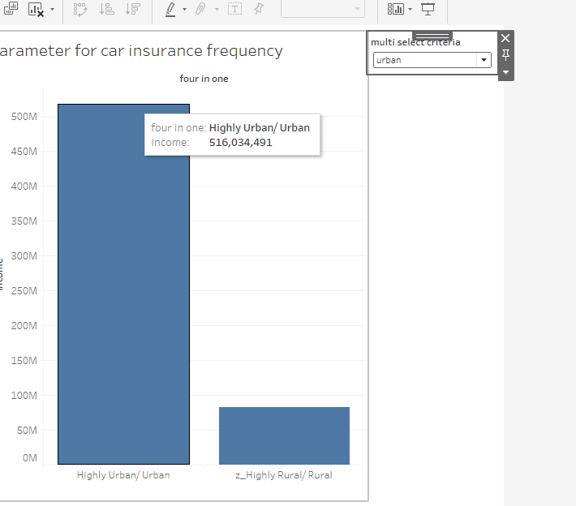

2. In All the worksheets used the income as filter:

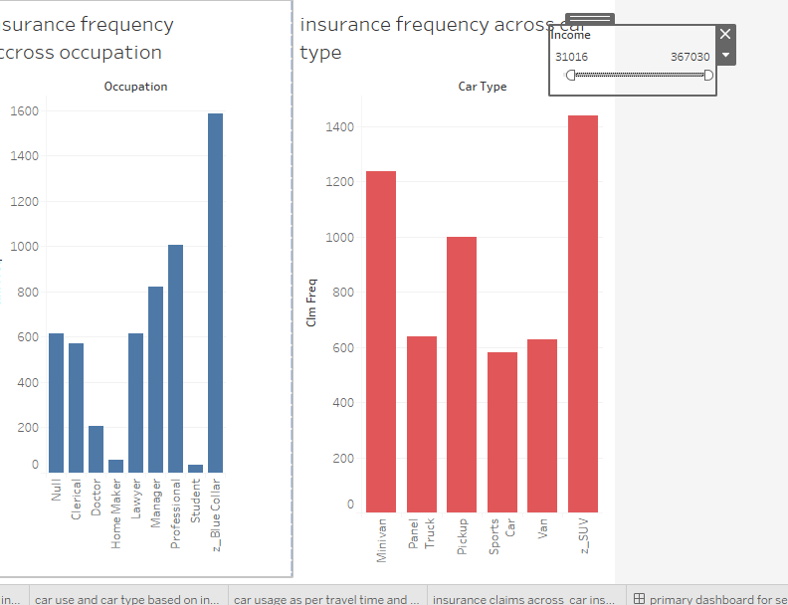

**4. Story layout**

**URL :**

<https://public.tableau.com/shared/SZ34GBC8Q?:display_count=y&:origin=viz_share_link>

1. Usually people with more income buy cars so car is used more in urban area, having z_blue collar as occupation, are mostly married people and who did at least bachelors while education. this is based on multi select parameters

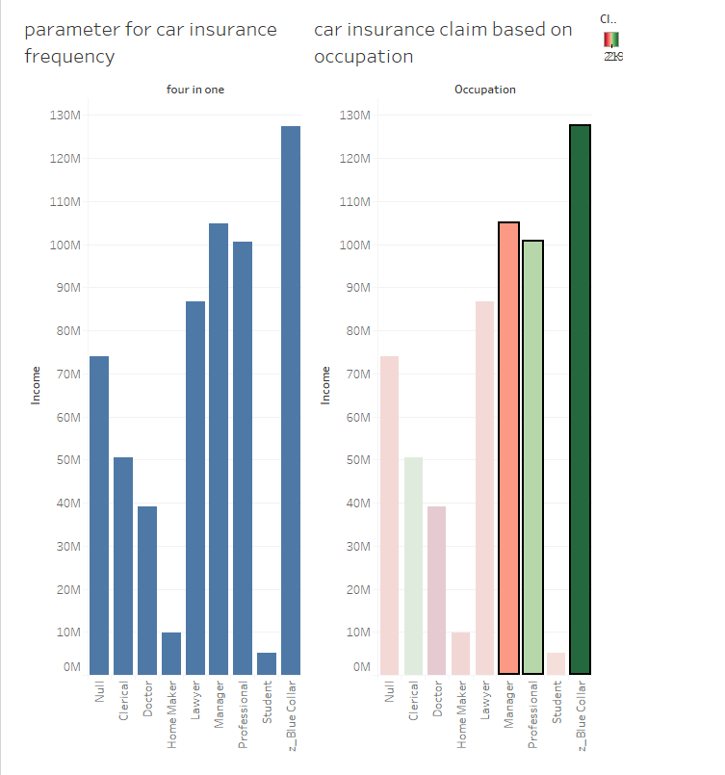

1. the car with more number of insurance years are z-suv and minivan and people whose birth year fall under 1946 to 1964 purchased more cars.

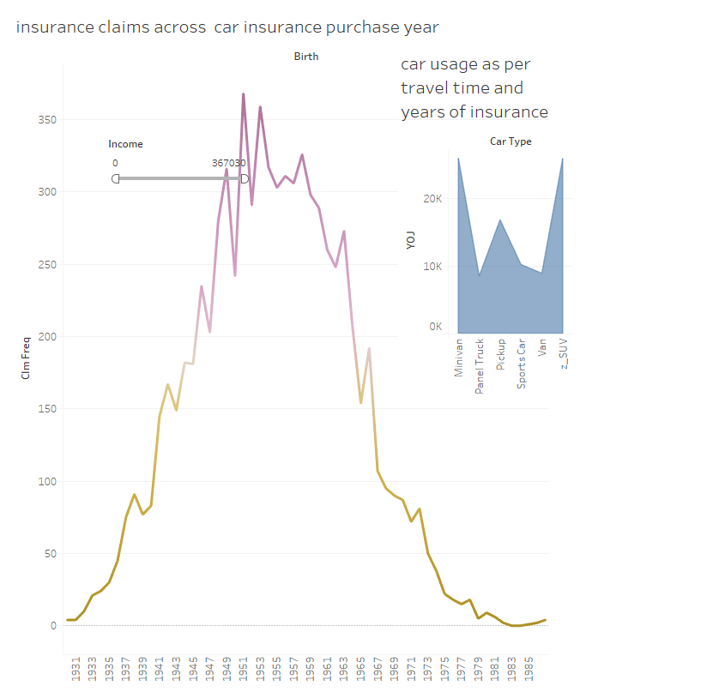

1. claim frequency for z_suv car for private use and pickup commercial use is high however when the income increases the panel truck for commercial use and minivan for private use is high.

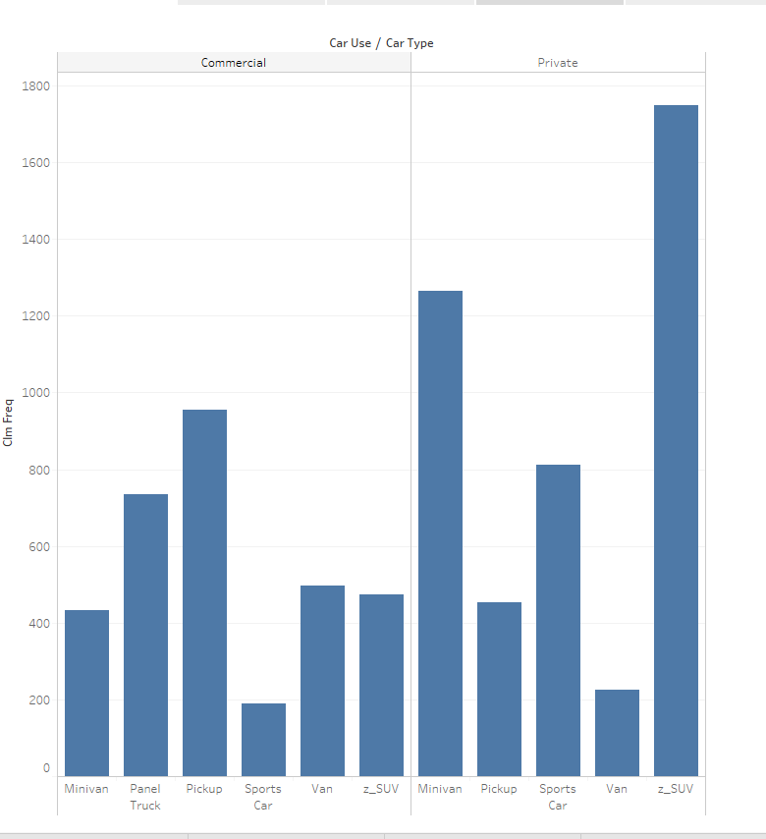

1. overall the insurance claims frequency of z_suv cars and people having z_blue collars jobs are more but as the income range increases managers and Panel truck car insurance frequency increases

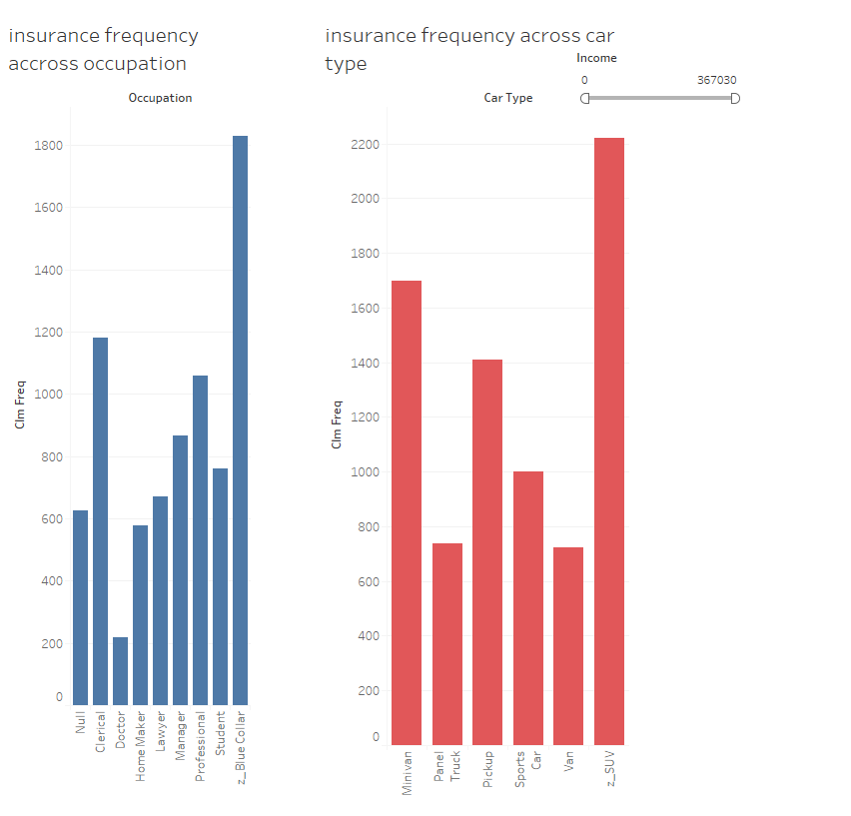

**5. Appropriate chart**

Here mostly we have chosen bar chart as it suits well to our data type but as per data we may chose other chats as well:

